Professional Skills Basic Analysis:

**Voter Turnout by Constituency:**

Average turnout overall was 65.0% in 2010 and 66.1% in 2015.

We can see from the following graphs that constituencies won by the Conservative and Green parties have the highest turnouts overall, with 68.2% and 70.0% respectively. The constituencies with the lowest turnouts appear to favour minor parties over the larger ones, however Labour held constituencies too have a low turnout rate.

We also observe that a change in turnout rate correlates with a change of leading party vote. All parties that won constituencies which increased in turnout also increased their lead over their opponents, while a decrease in turnouts made for a weaker victory.

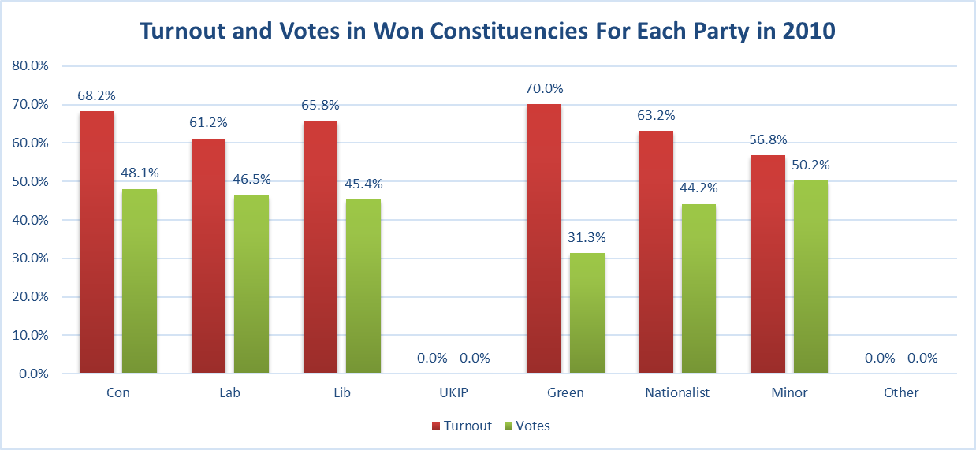



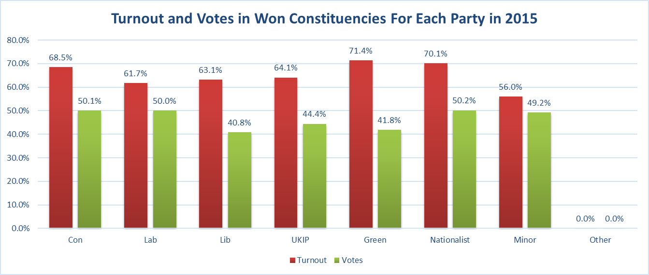



**Swings:**

Region 2:

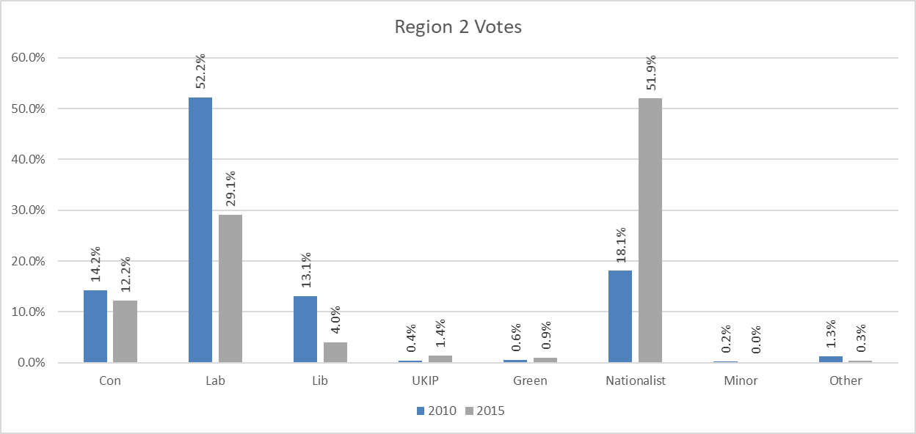



In region 2 we can observe the large shift in support in favour of the Nationalist party, which gained over three times more votes in 2015 than it won in the 2010 election. These votes appear to have come from ex-Labour and ex-Liberal-Democrats, as these parties appear to have suffered the most from this shift, with the Liberal Democrats losing more than half their support. The Conservative party did lose votes, but their overall support seems to have remained largely unaffected.

Wales:

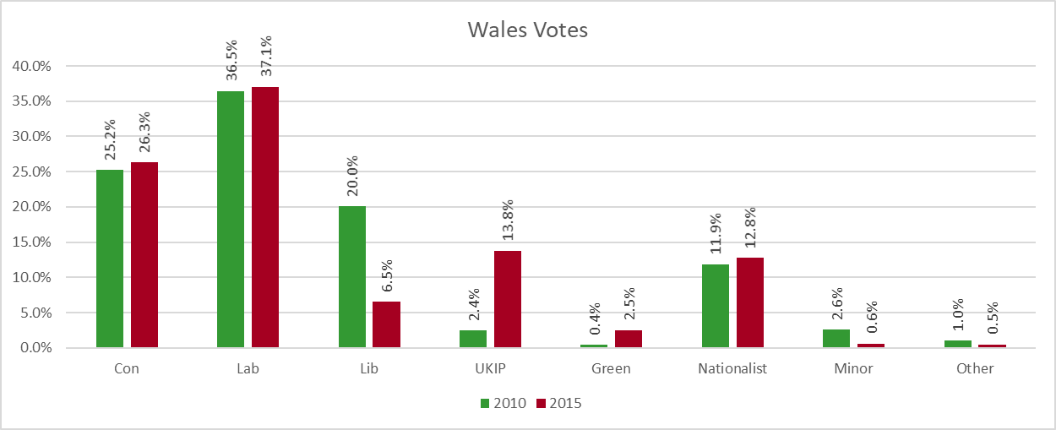



In Wales we observe a large swing from the Liberal-Democratic Party to the UK Independence Party. The Conservative and Labour parties have similar votes in each election, slightly higher in 2015. While their overall votes remain much lower than those of the leading parties, it is worth noting that the Green Party received six times as many votes in 2015 than it did in 2010.

UK:

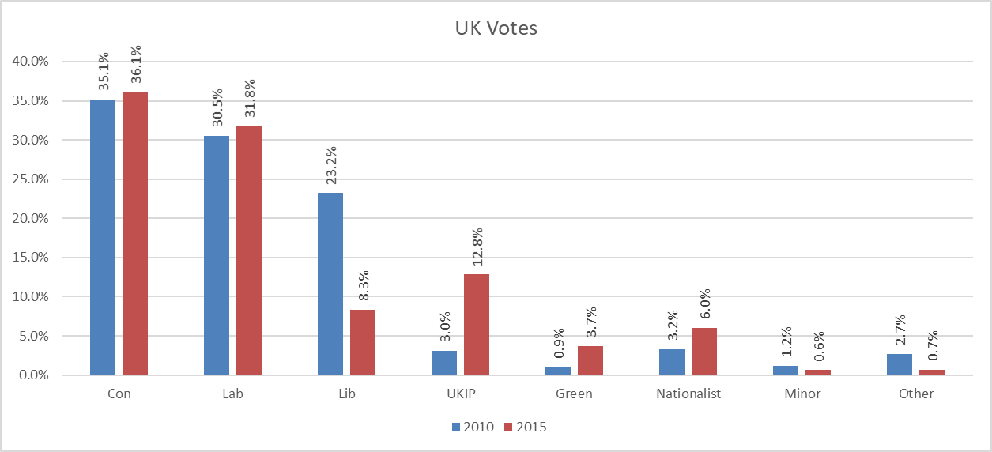



The overall changes in the UK as a whole are very similar to those in Wales, with the Liberal-Democratic party losing a large portion of their votes and UKIP taking their position as the third largest British party. No significant shifts in either the Conservative or Labour parties, which both seem to slightly strengthen their positions. Support of the Nationalist Party has doubled, which can be related back to the large swing of votes in Scotland.

**Incumbent Effect:**

Using the IF and COUNTIF functions, we can show and find the number of recurring winners in the 2015 election.

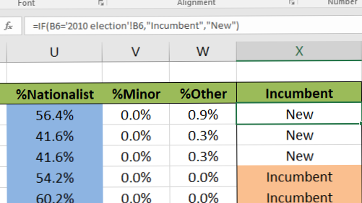





In 2015, 453 of the 650 constituencies (69.7%) were won by winners in 2010, with only 197 won by new candidates (30.3%). This supports the idea of there being an “Incumbent Effect” as a current MP has a much higher likelihood of being re-elected. While a previous winner does appear to be significantly more likely to win, they do not seem to gain a huge number of votes for the following election, although there is still an increase. These candidates won an average of 50.5% of votes in their constituencies in 2015, compared to 47.1% in 2010 (increase of 7.2%).